**Dhiraj Gurnani**

**SJSU-ID: 010813023**

Heroku: Front-end:

**Intro:**

Heroku is cloud based paas service supporting several programing languages. Heroku was acquired by salesforce.com initially it was only supported for Ruby but after adding sources node js and all are also supported.

**Installing heroku.:**

How does it work.

<https://devcenter.heroku.com/articles/getting-started-with-nodejs>

introduction

Official website of heroku where we get the tutorials of how to do it. This link gives you the idea of how to install the heroku downloading the heroku tool belt. Further we have to upload the whole code in the git and then deploy the app into heroku. So heroku will generate a link by going to that link we can open your project in the web browser. I got the whole thing from the above site and also referring the videos.

**Steps for installation:**

1 Introduction

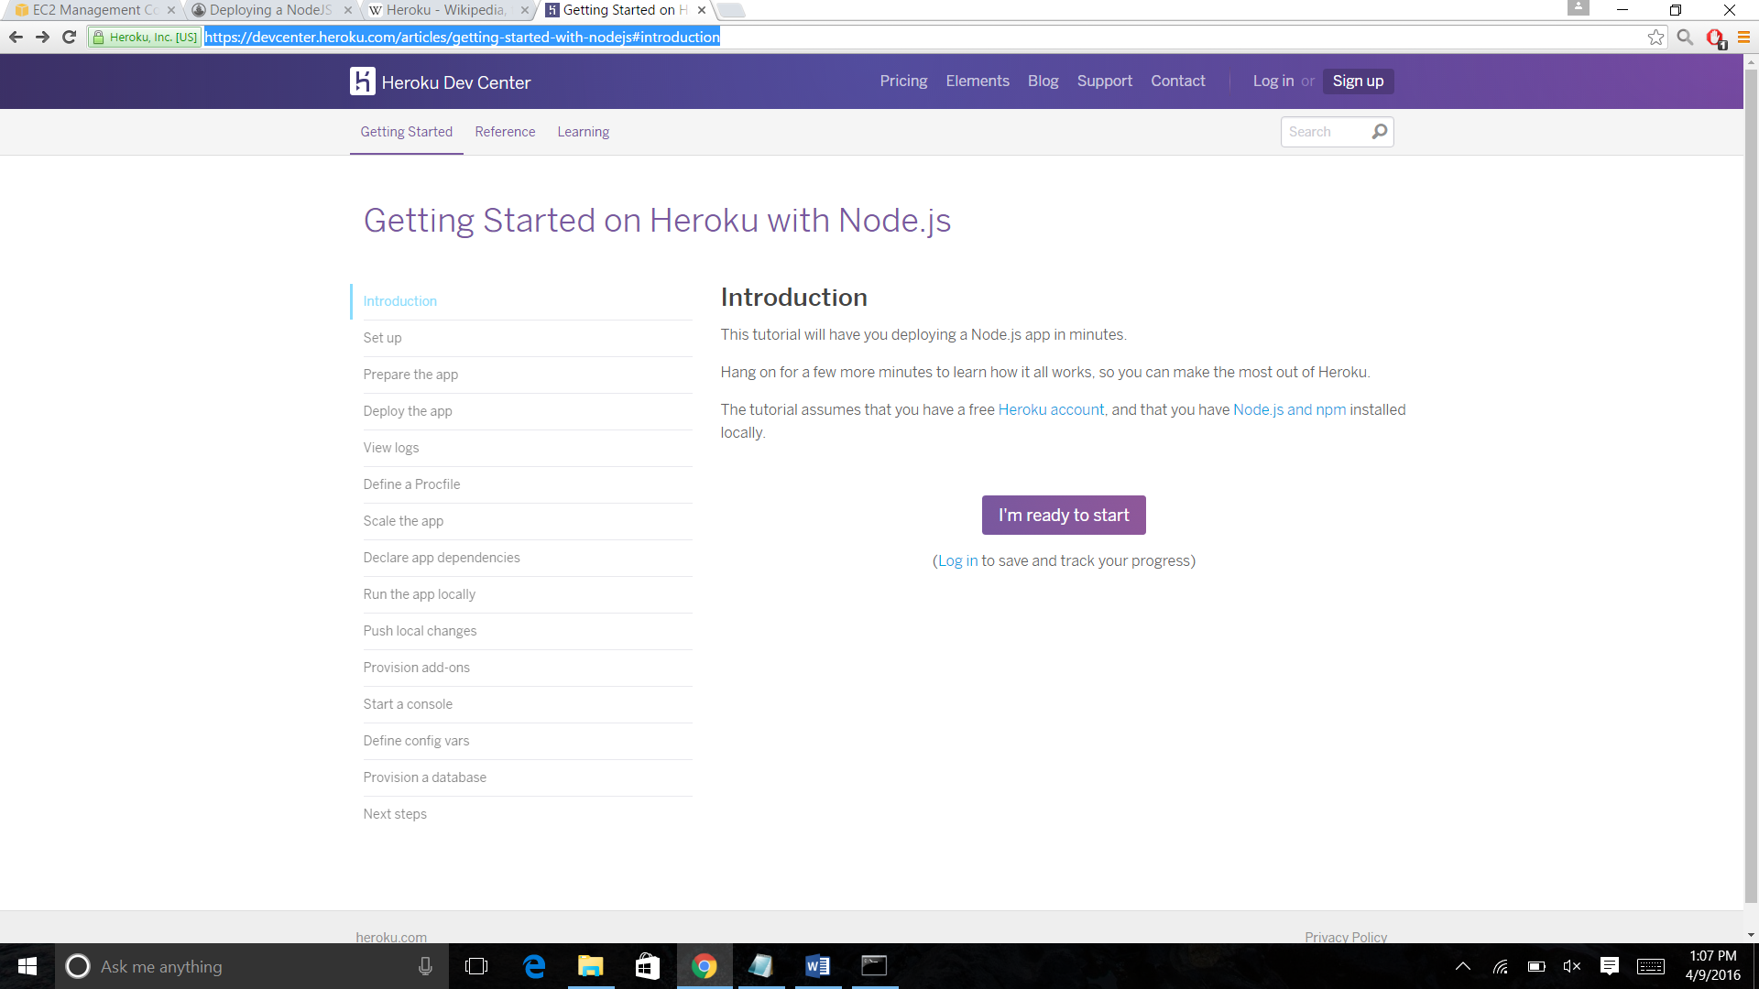

2. Setup: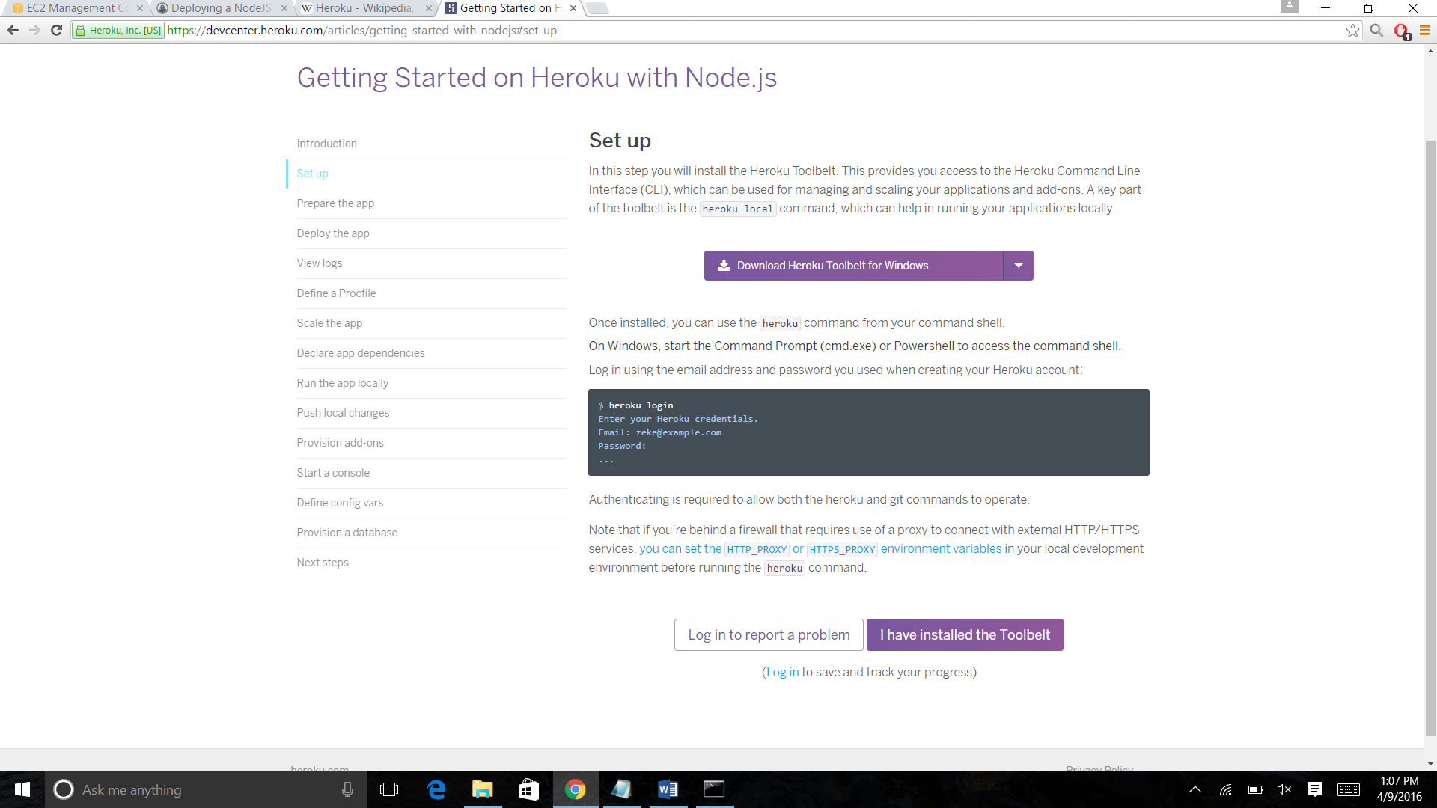

3. Prepare the app

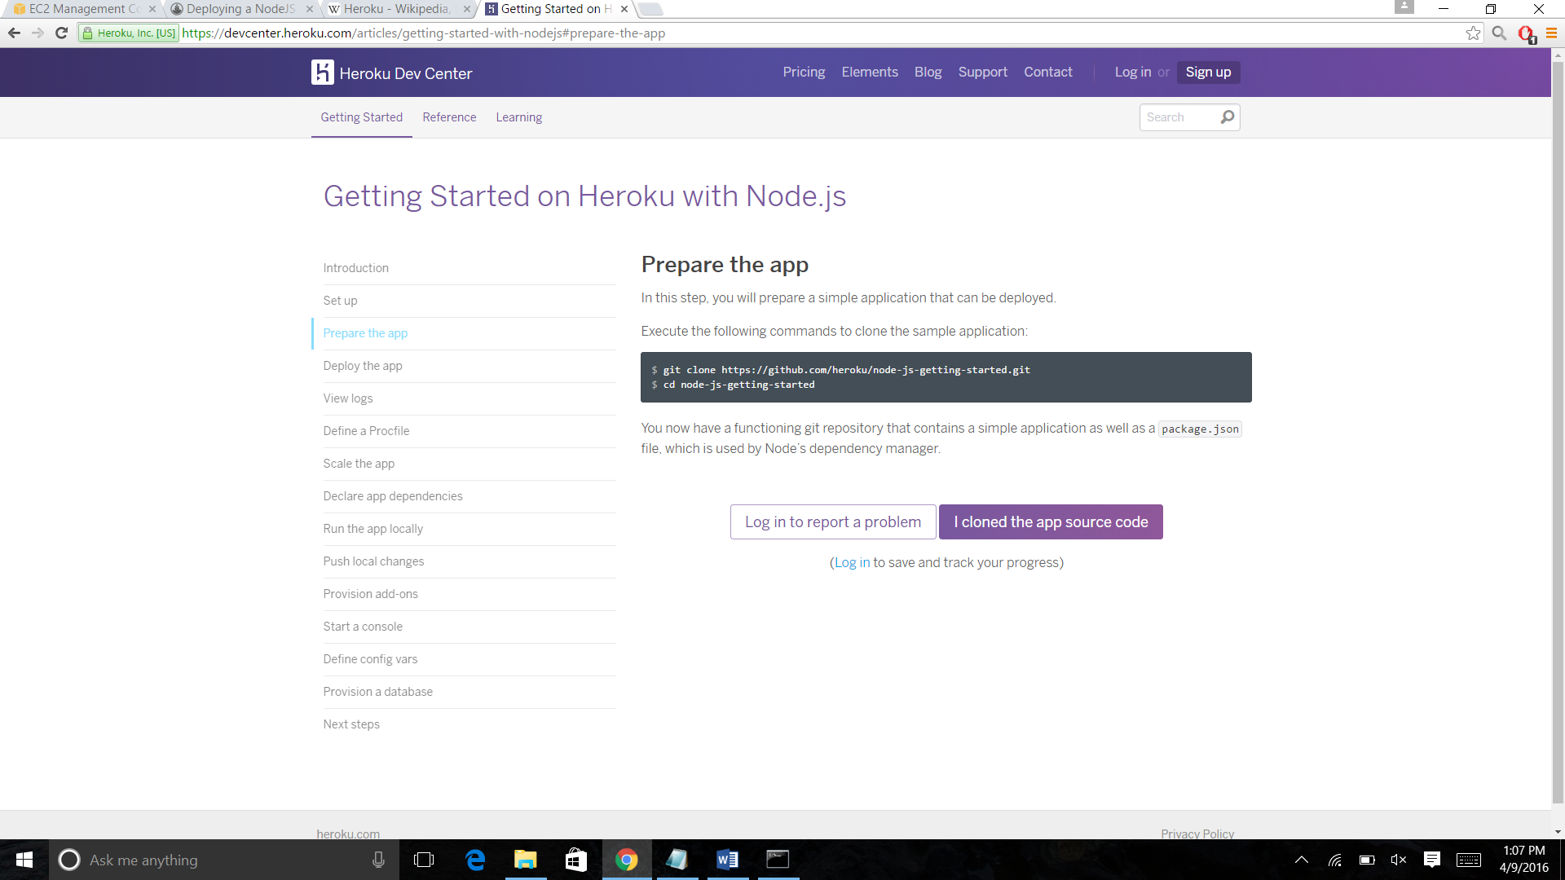

4. Deploy the app

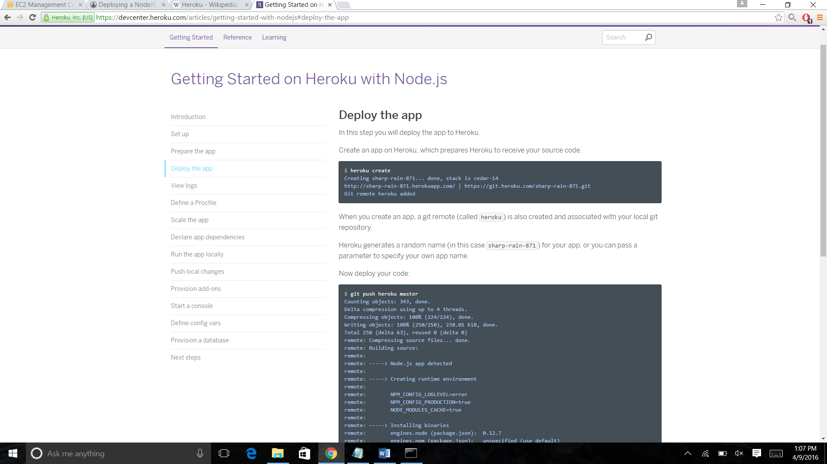

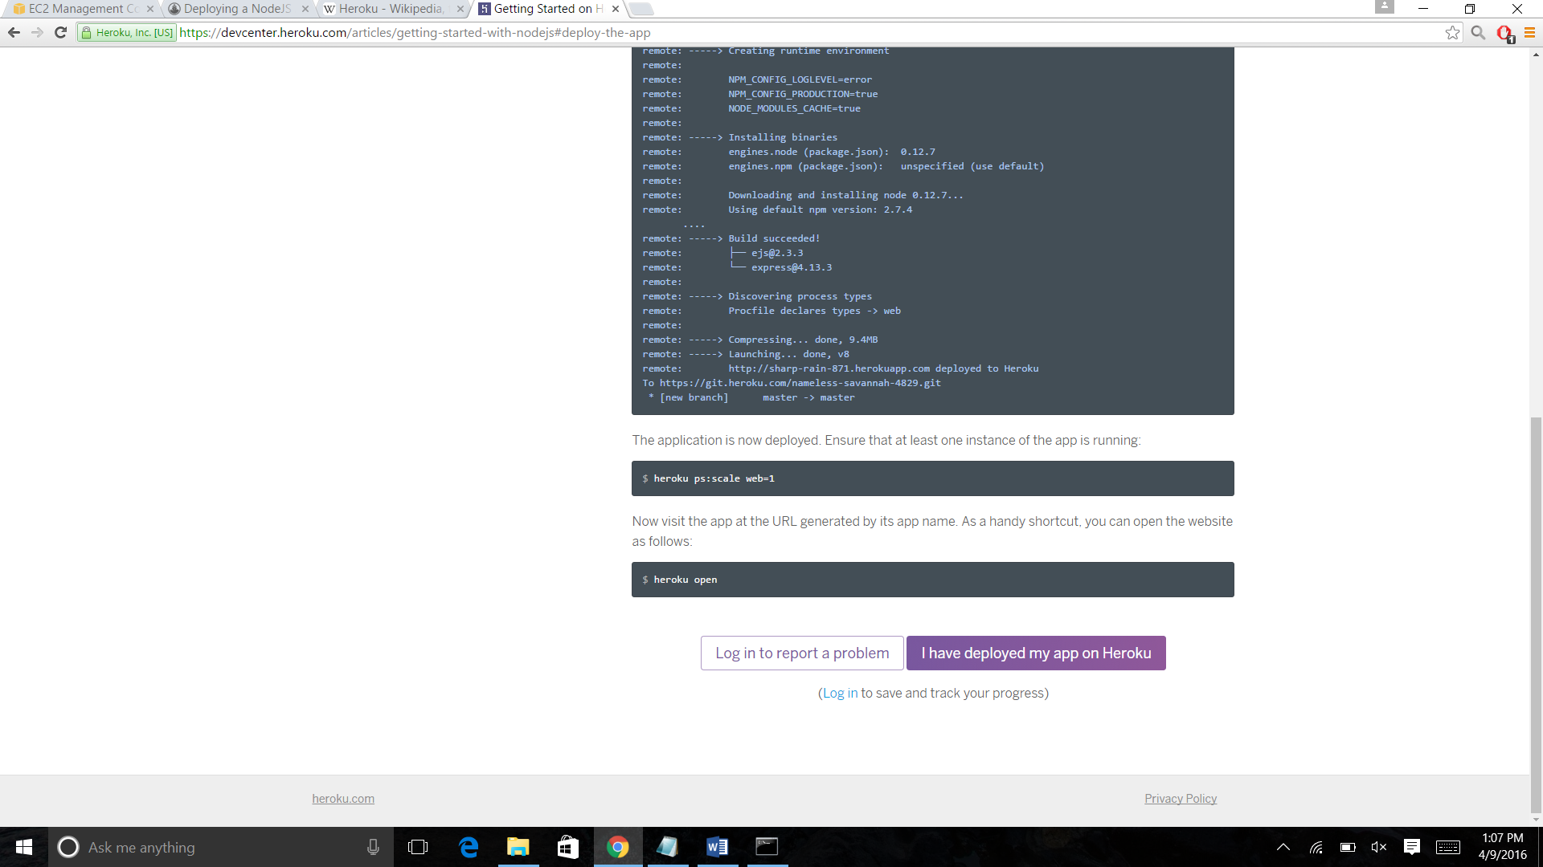

5. Getting started on Heroku with Node.js

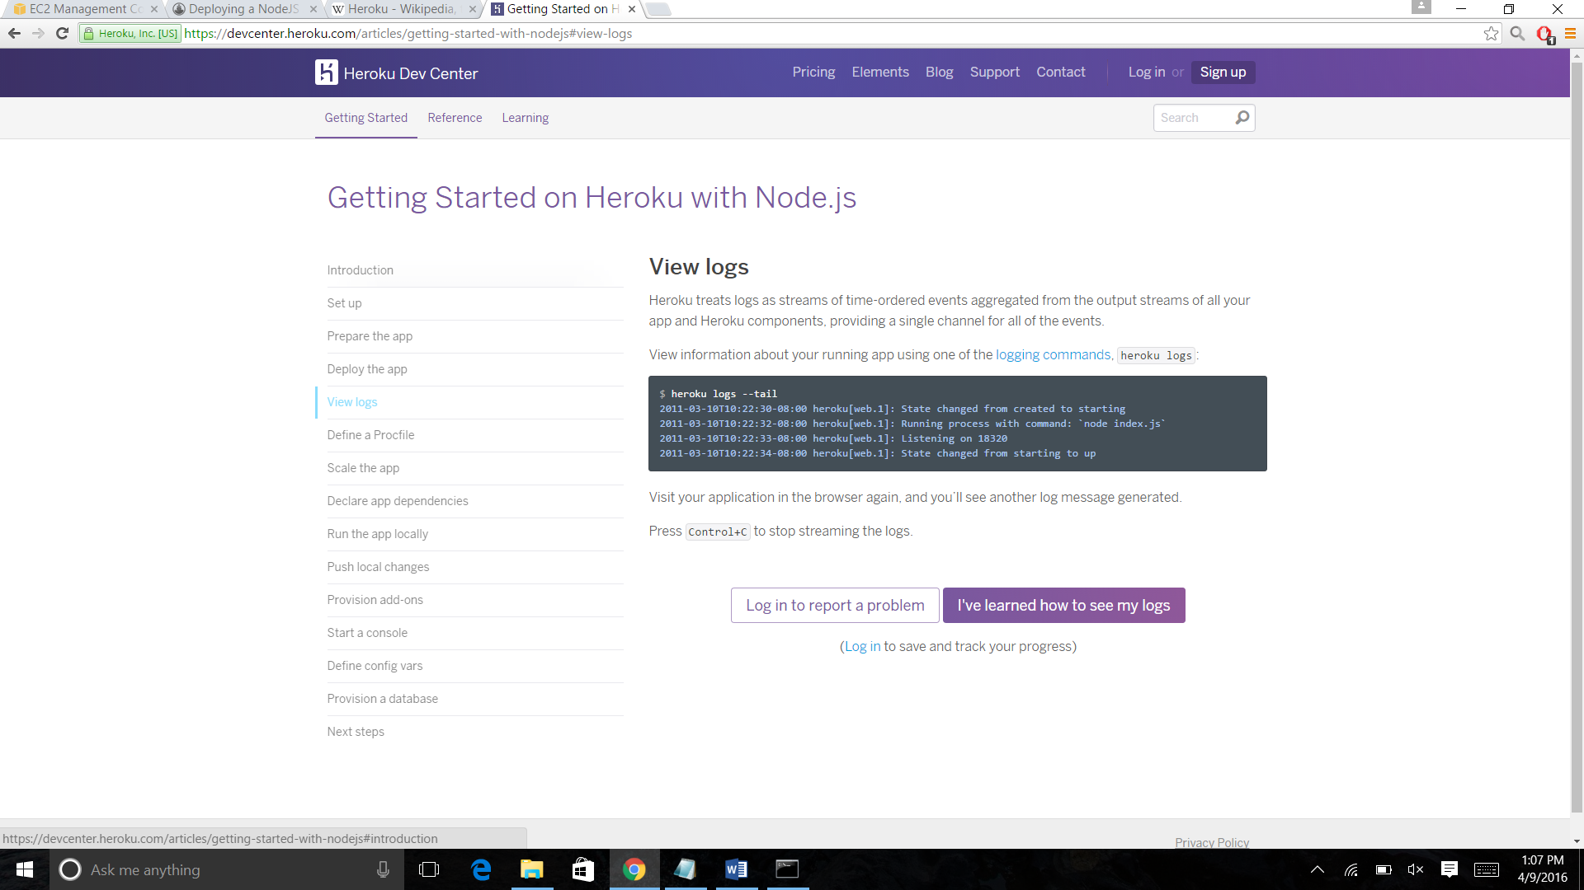

6. Define a Procfile

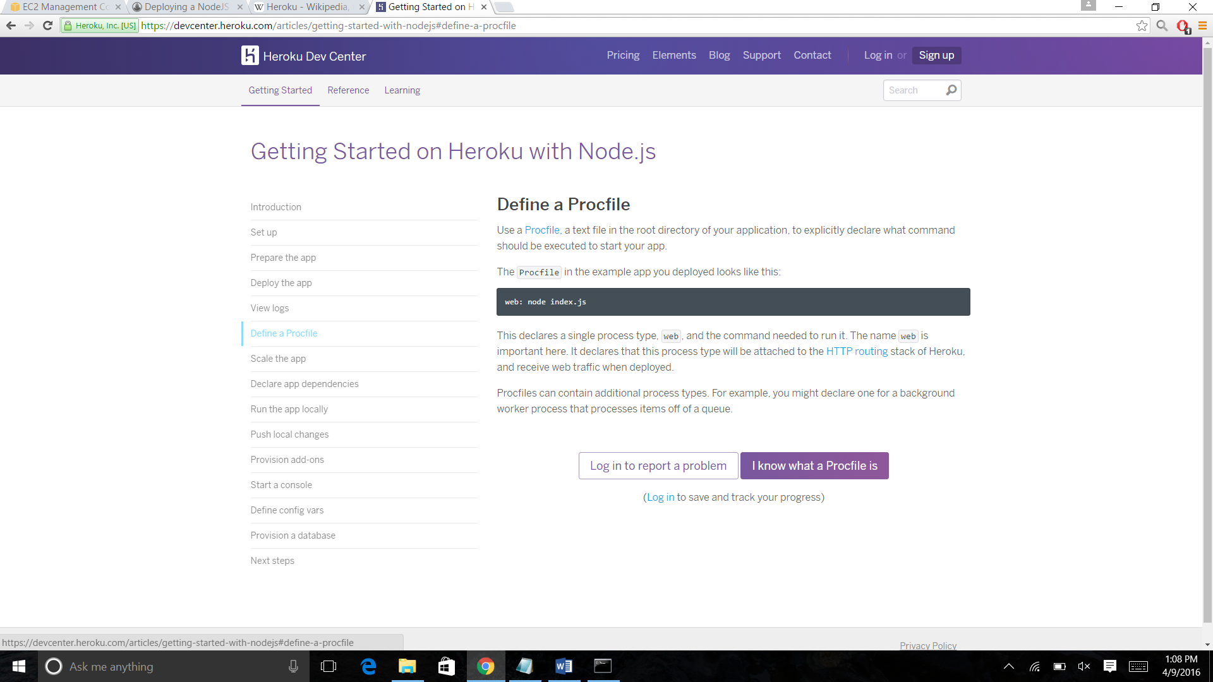

7. Scale the app

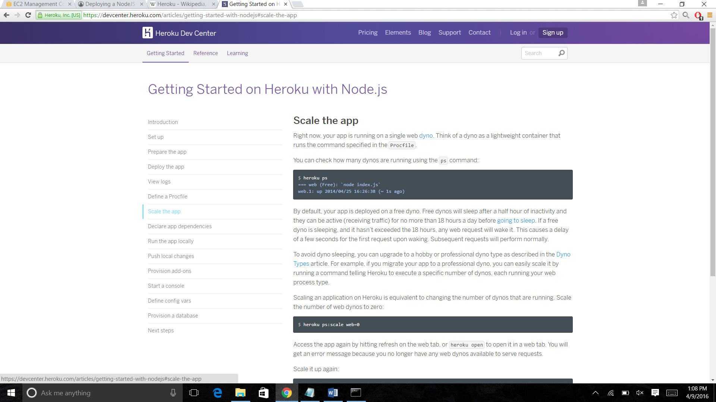

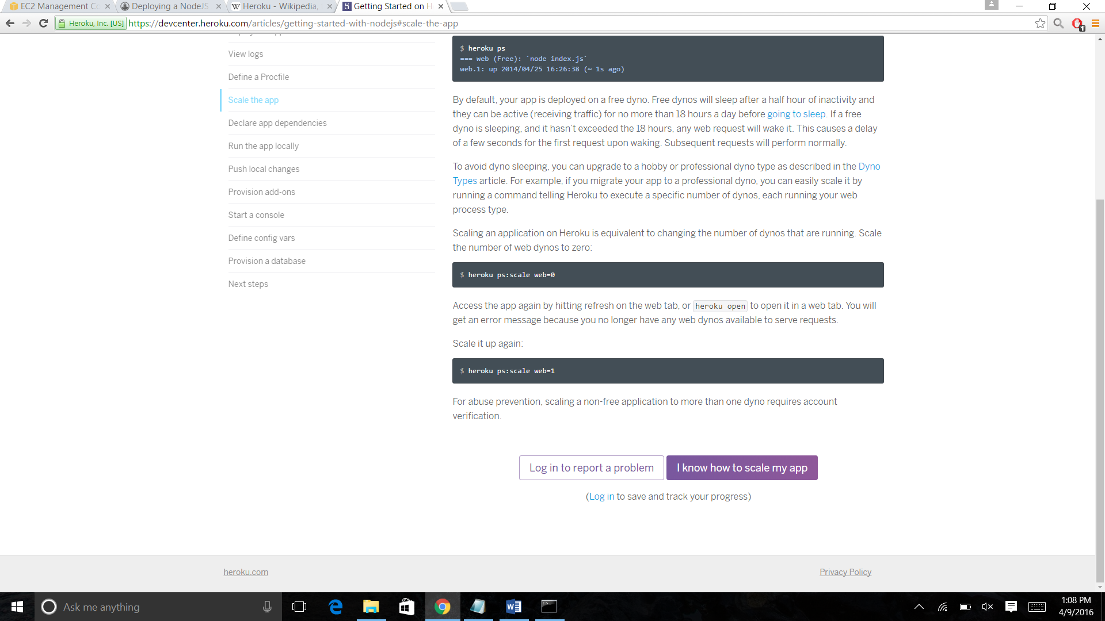

8. Declare app dependencies

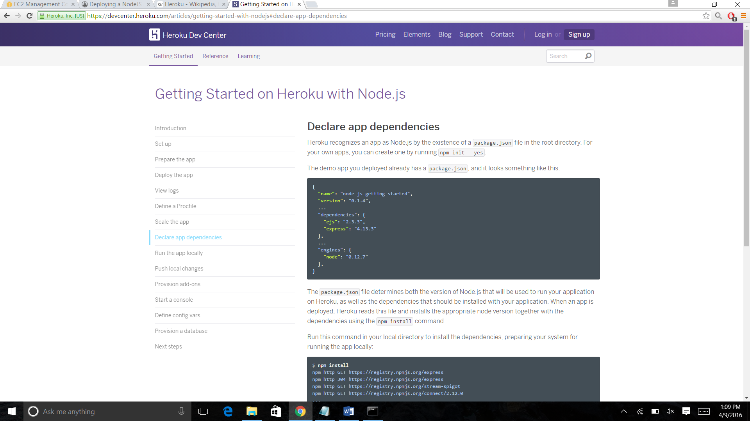

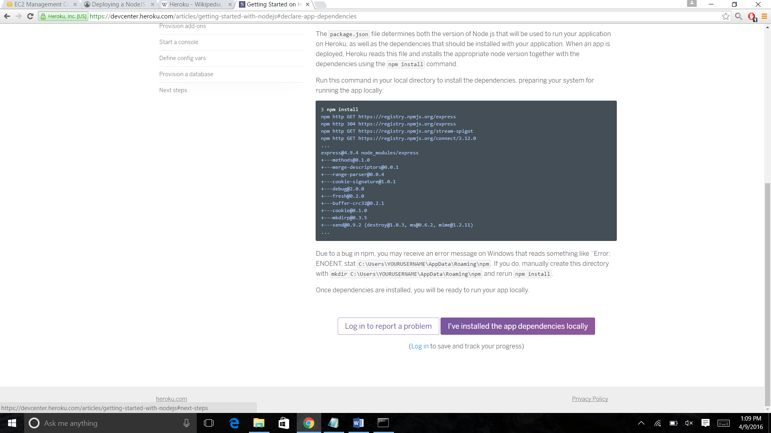

9. Run the app locally

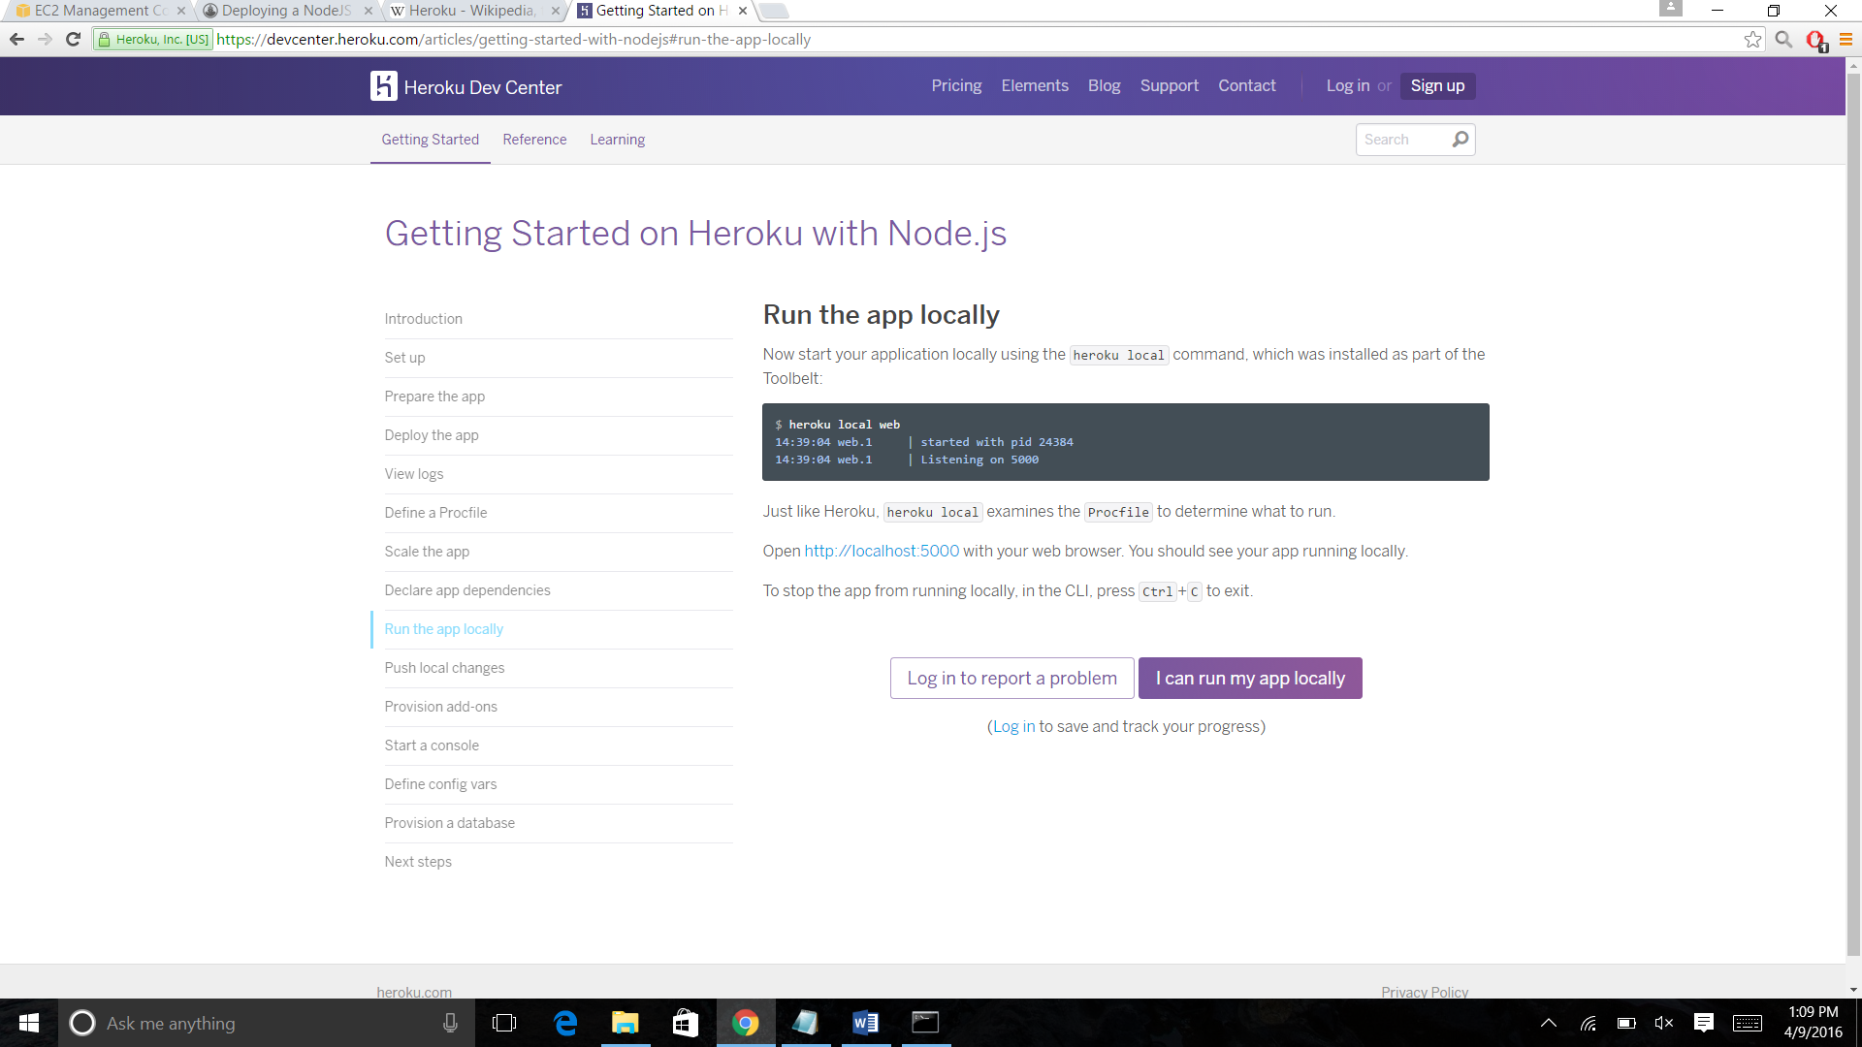

10. Push local changes

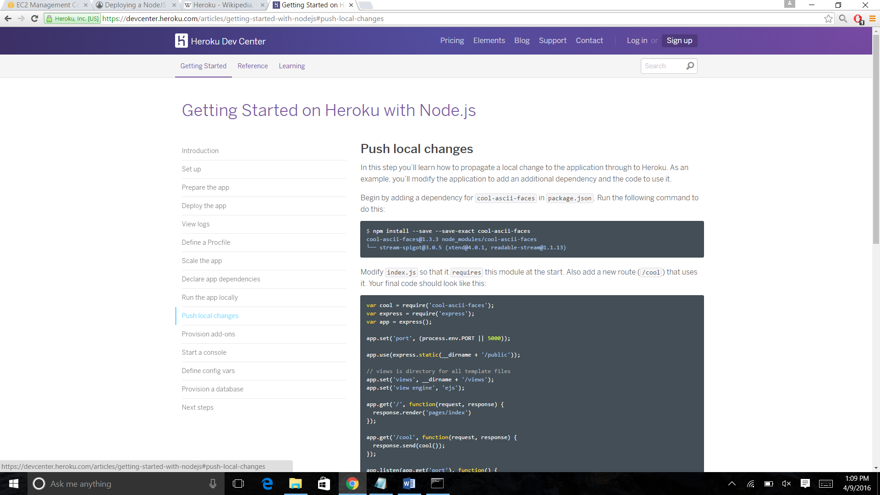

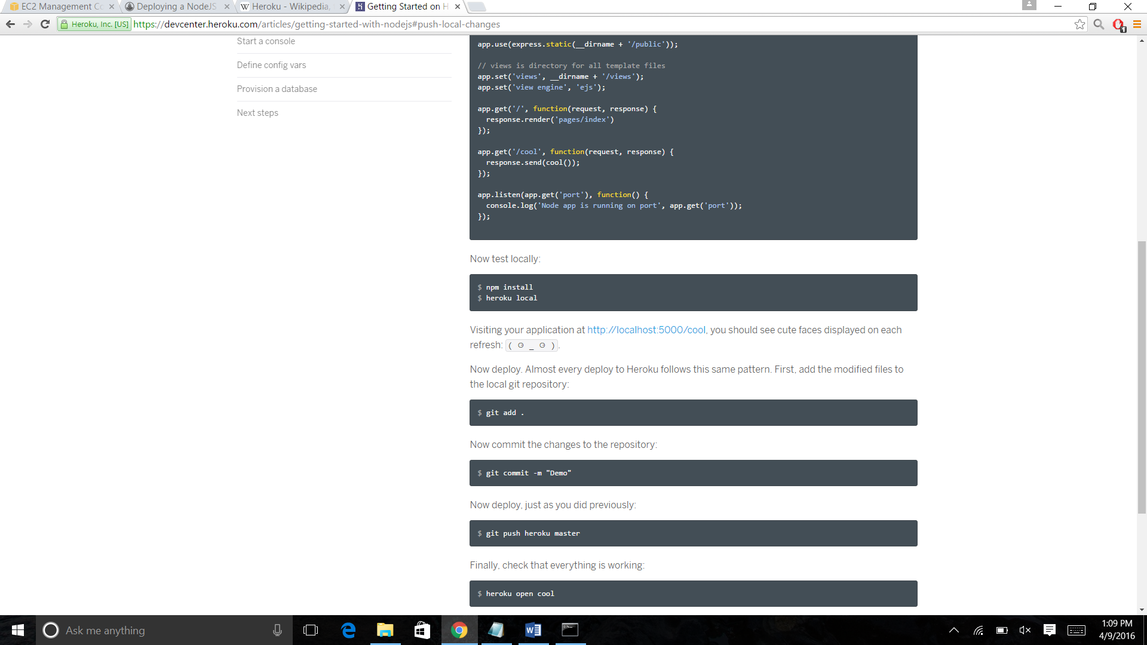

11. Provision add-ons

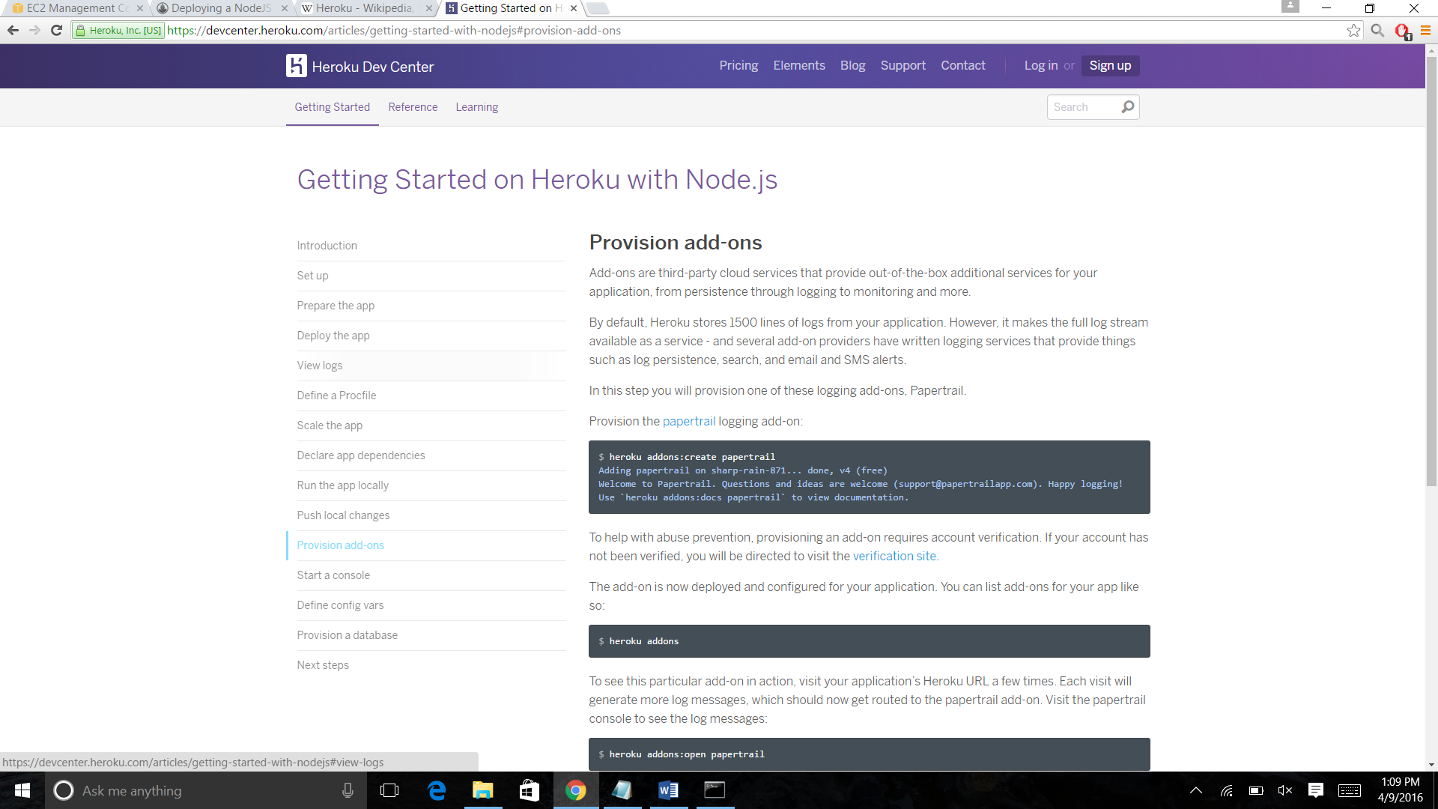

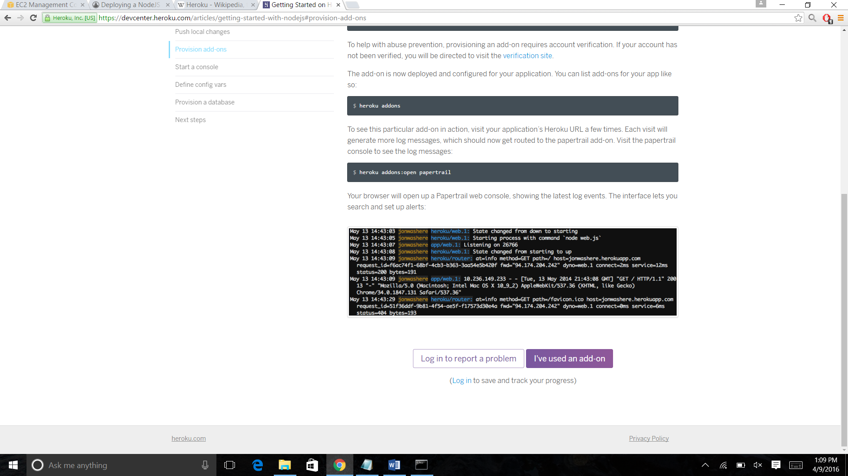

12. Start a Console

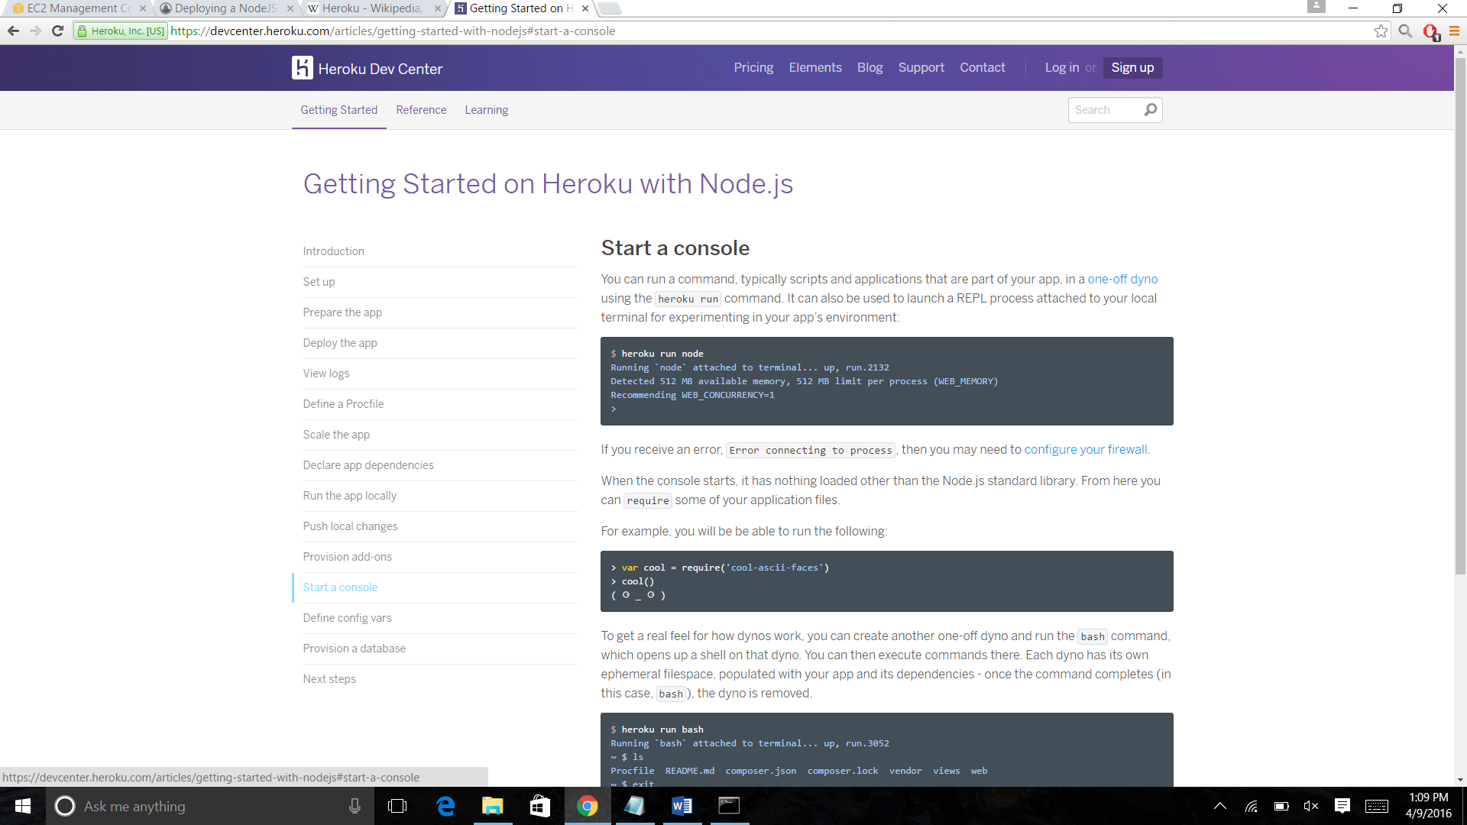

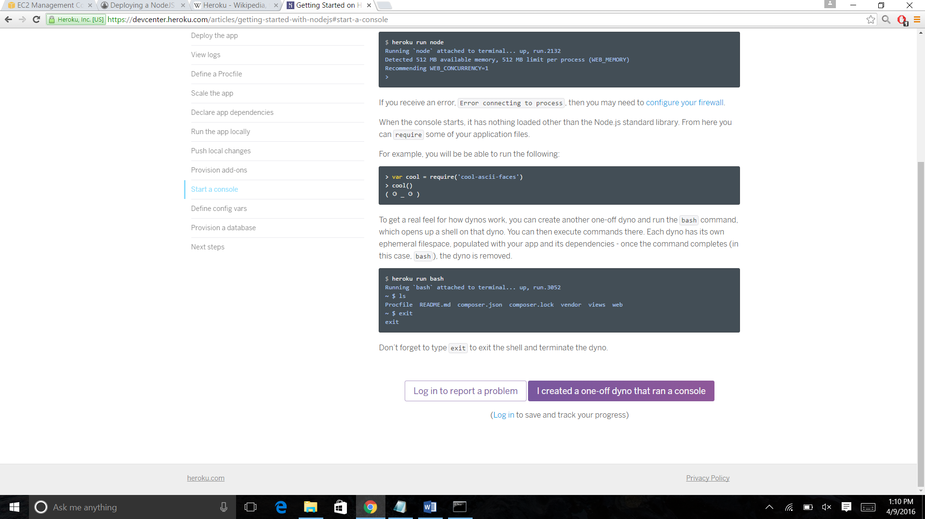

13. Define config vars

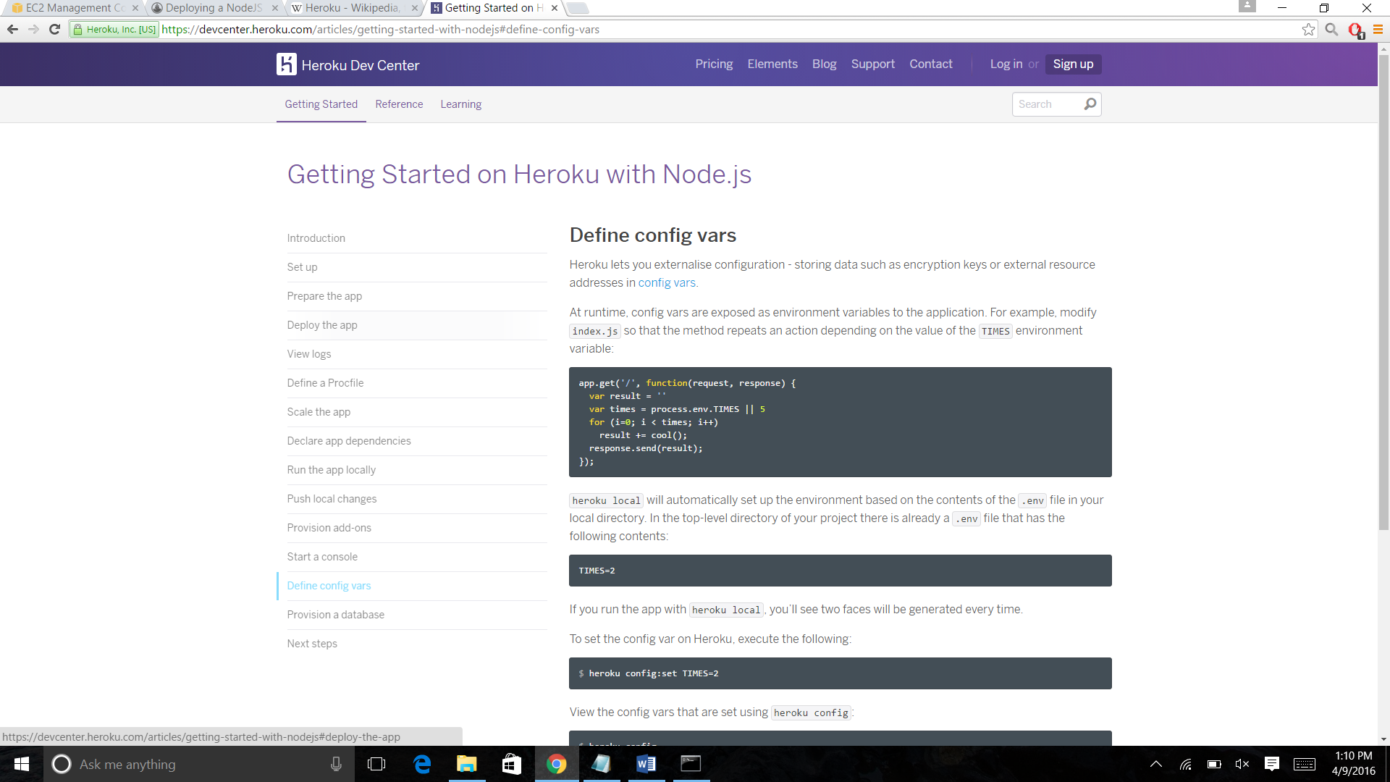

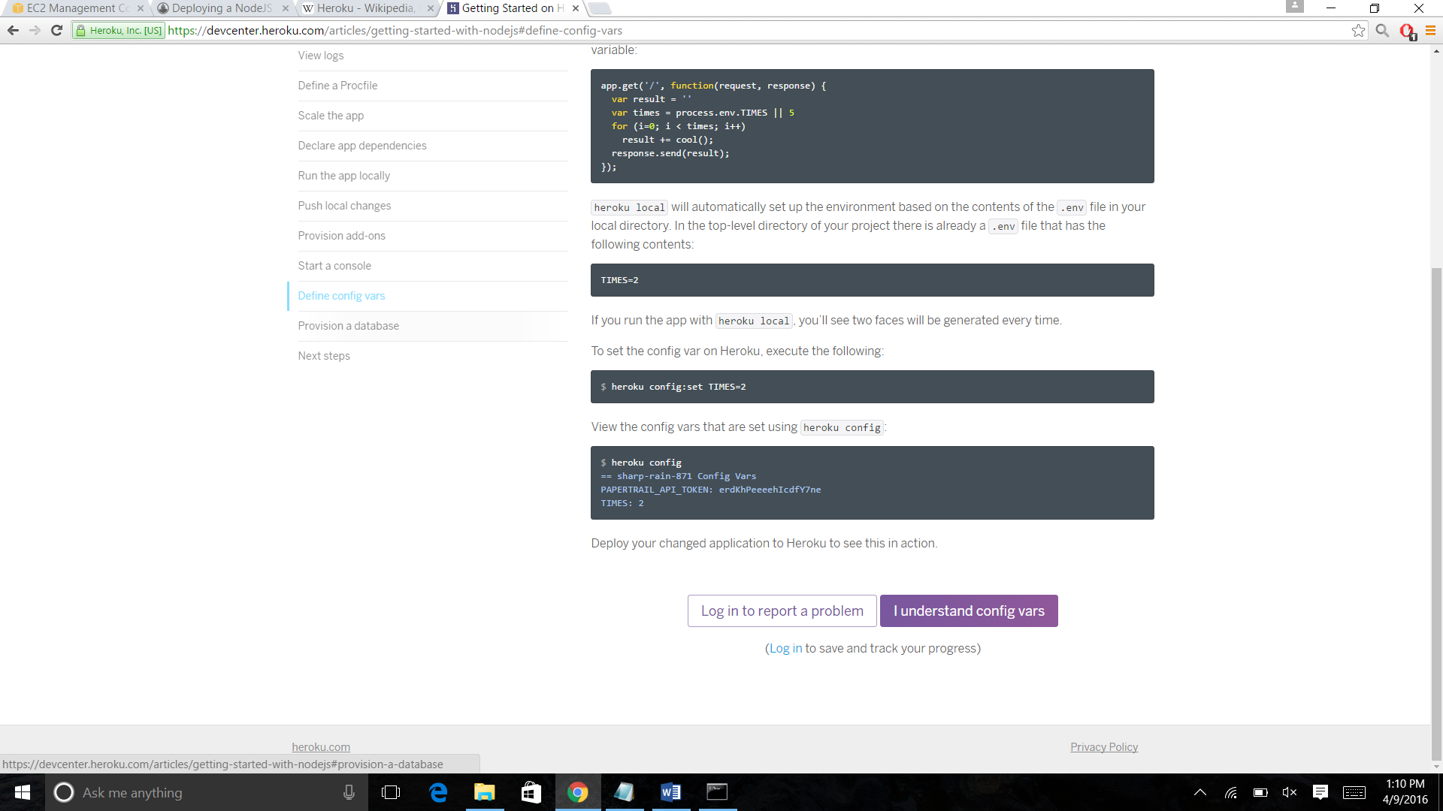

14. Provision a database

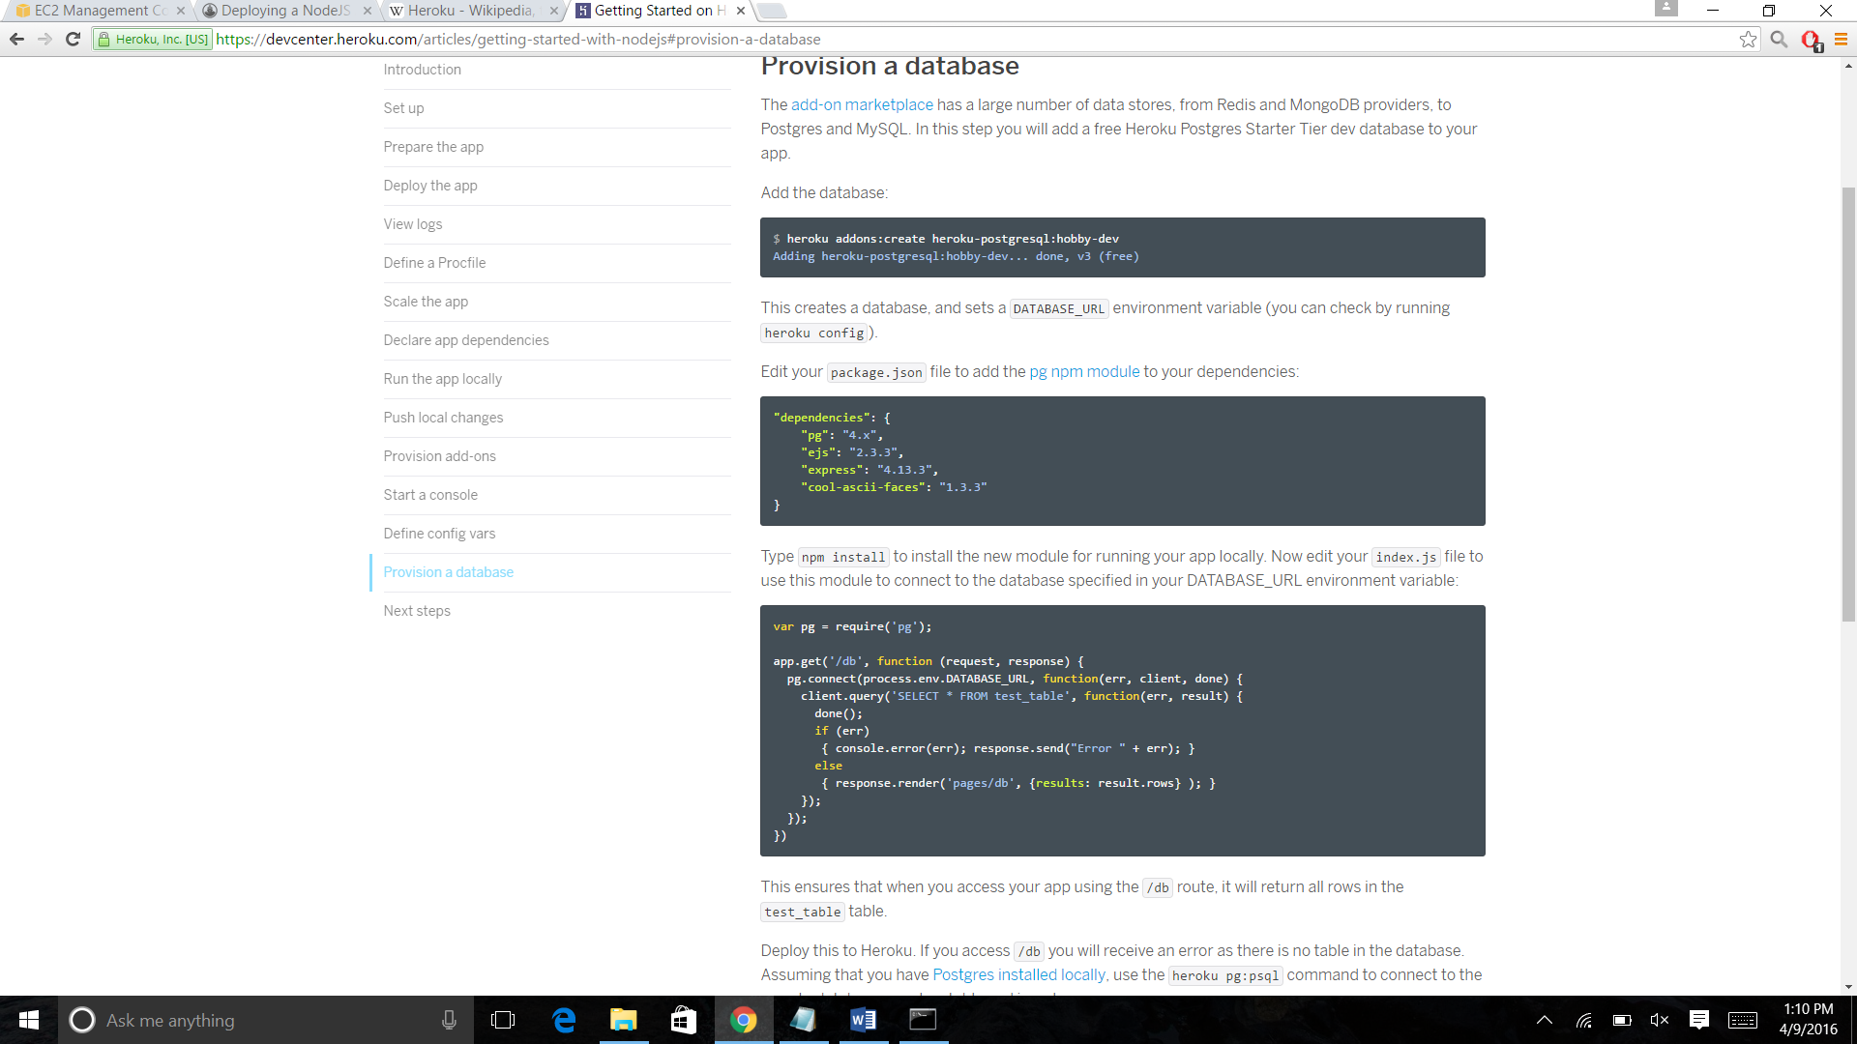

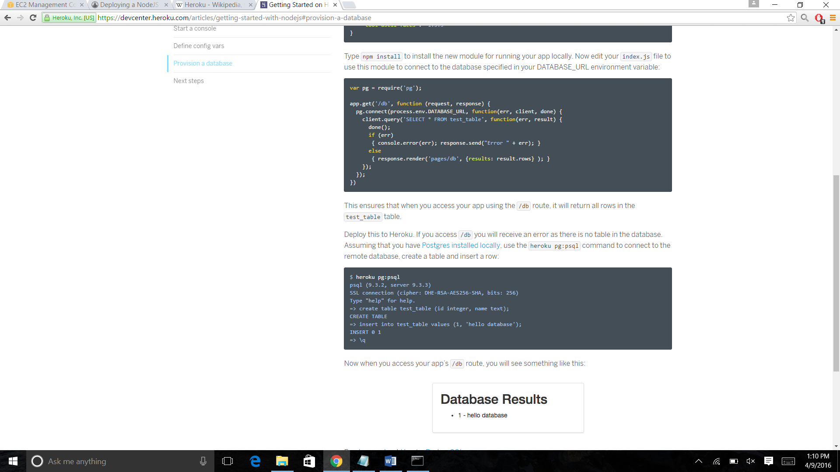

Other installing tips I got from the following video:

Here are there links:

https://www.codeschool.com/screencasts/heroku

https://www.youtube.com/watch?v=uLF_hmtxAsY

<https://blog.codeship.com/heroku-github-nodejs-deployment/>

**Installation done on the local machine:**

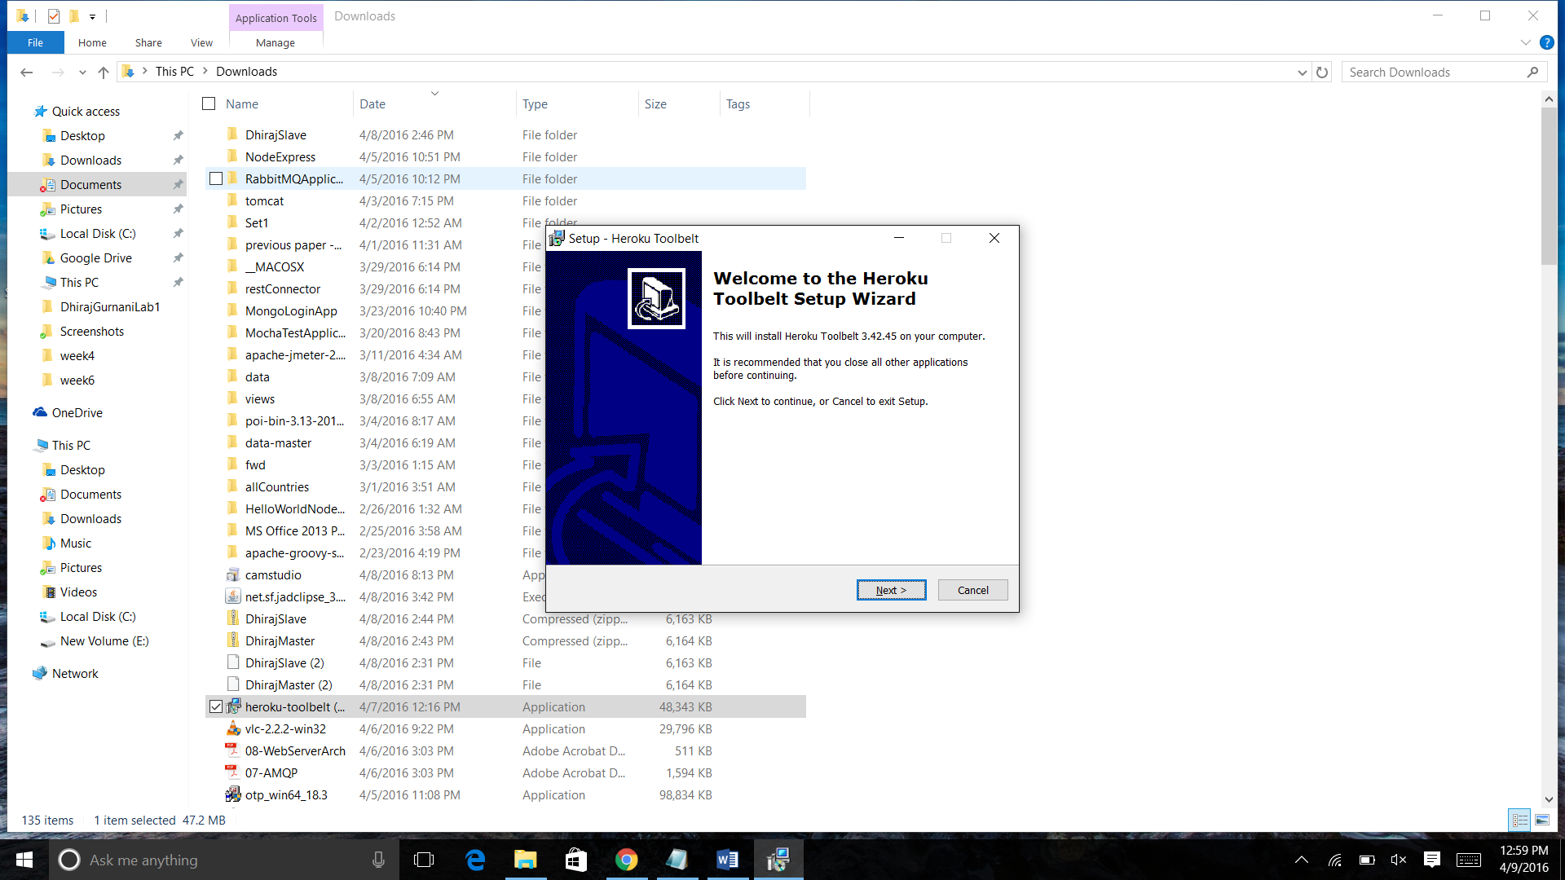

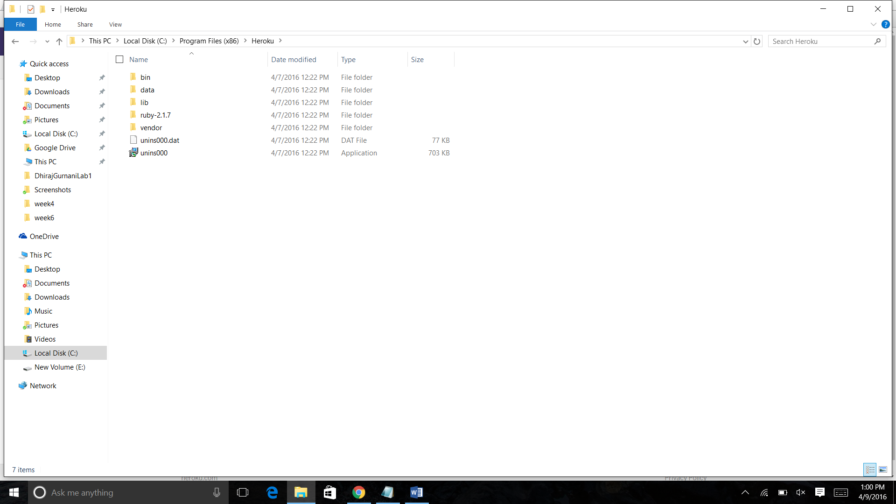

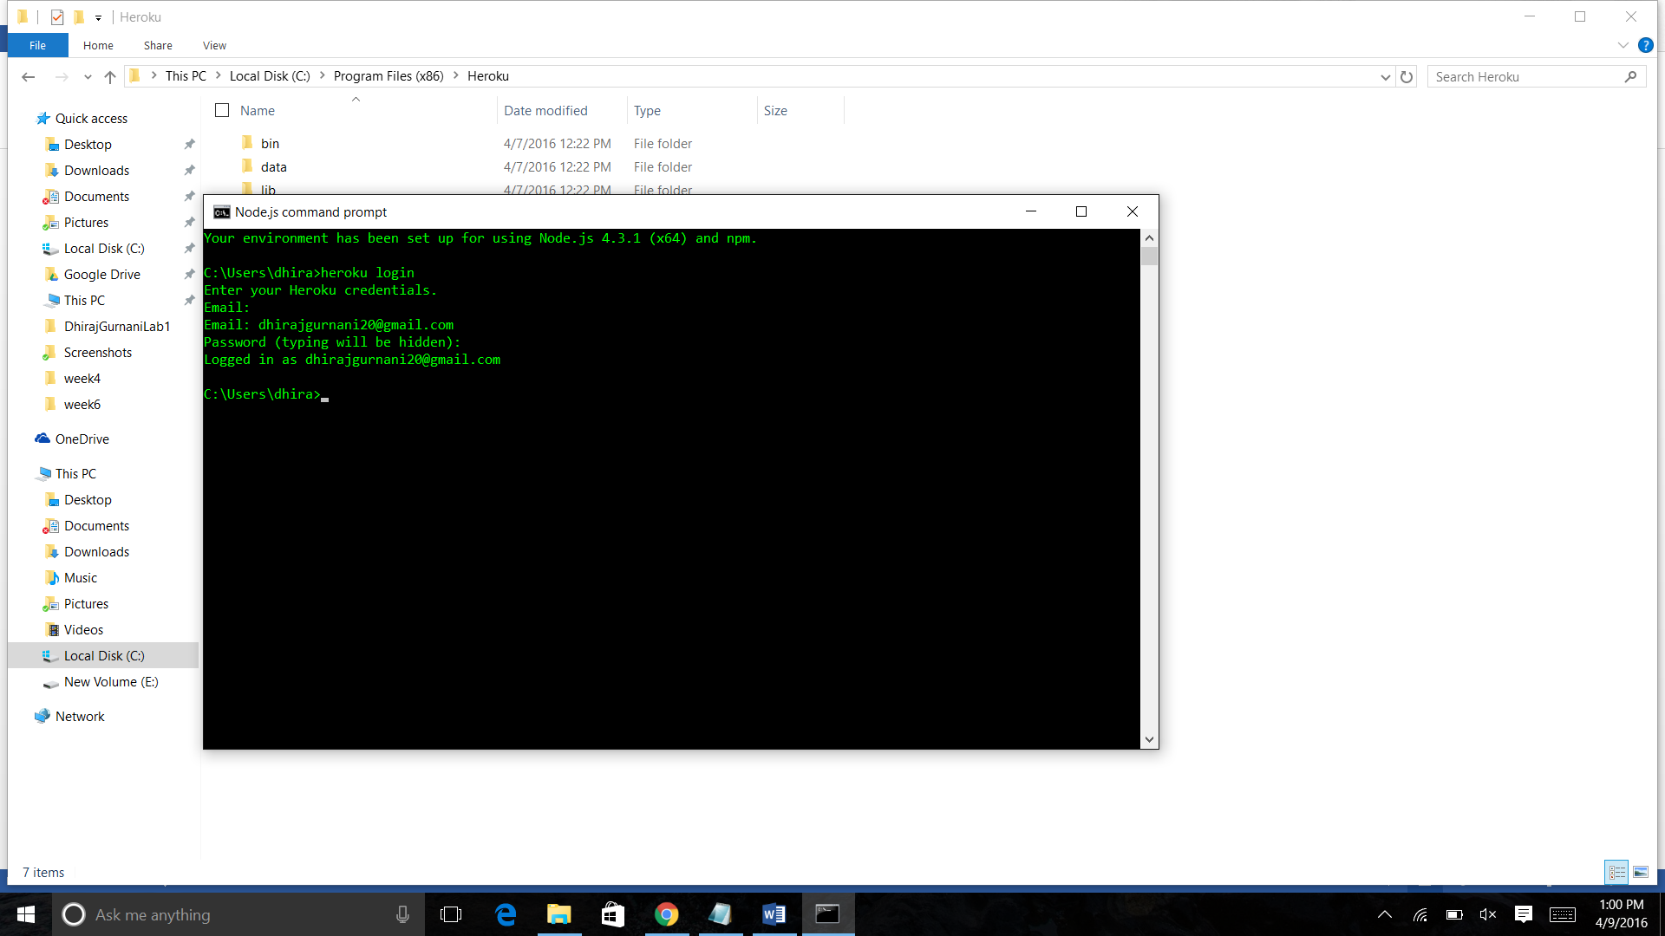

Summary:

This shows how do we install and deploy a node.js on heroku.